Civil war in Liberia

UNSC Resolution: | 1478
Date of adoption: | 6-May-2003
Operative paragraph: | 31
Demand number: | 1478,3111

Sarah-Myriam Martin-Brûlé

Wording of demand

authorize the Approach and Control Unit at Robertsfield International Airport to provide regularly to the Flight Information Region in Conakry statistical data related to aircraft listed pursuant to paragraph 29 above

List of addressees of the demand

Government of Liberia

Short-term compliance

Description of the addressee(s)’ conduct

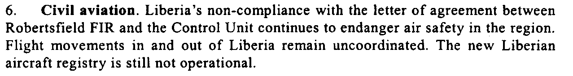

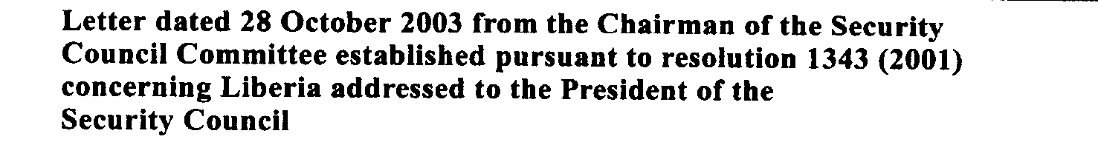

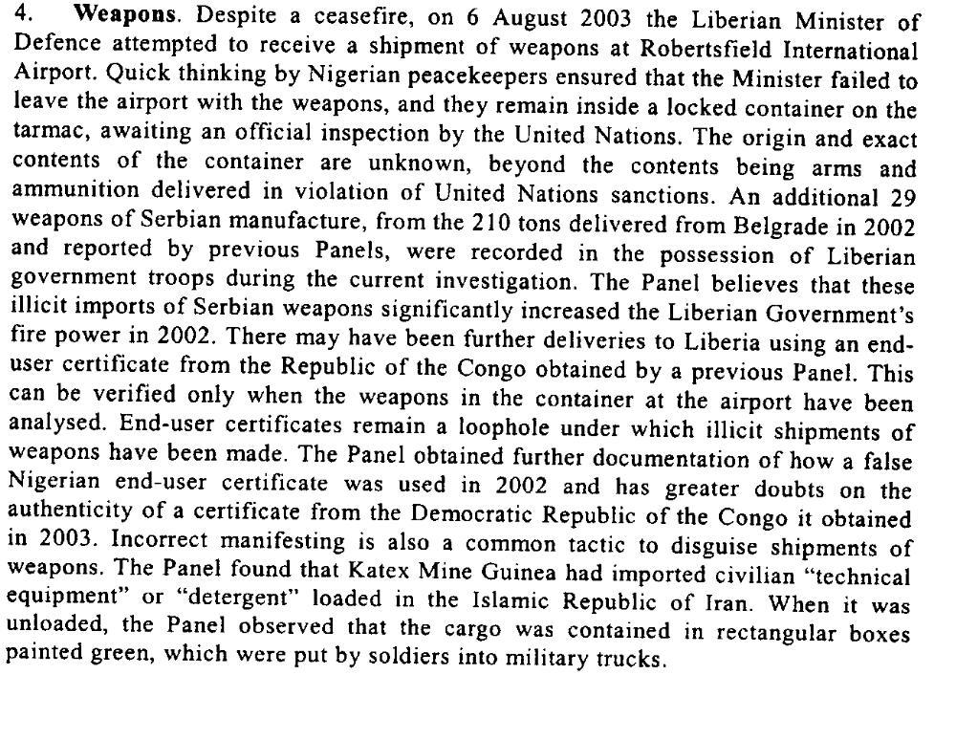
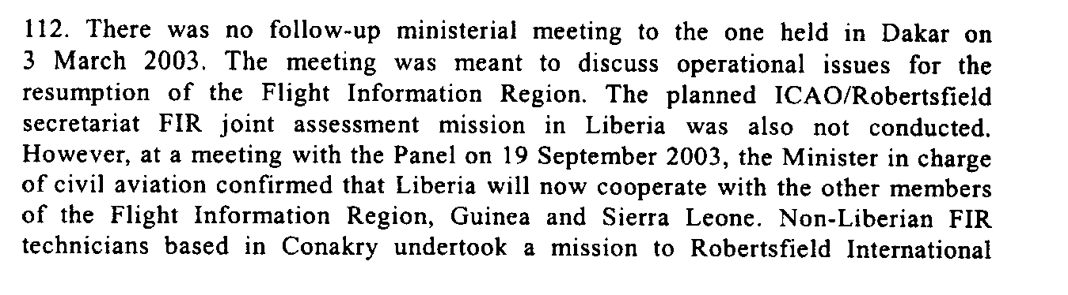

United Nations Security Council, Letter dated 28 October 2003 from the Chairman of the Security Council Committee established pursuant to resolution 1343 (2001) concerning Liberia addressed to the President of the Security Council.

Assessment

Short-term compliance
X No or marginal compliance (1) | Medium low compliance (2) | Medium high compliance (3) | Full or almost full compliance (4)

Considerations underlying the assessment
The Government of Liberia did not authorize the Approach and Control Unit at Robertsfield International Airport to provide regularly to the Flight Information Region in Conakry statistical data related to aircraft listed pursuant to paragraph 29 above

Medium-term compliance

Description of the addressee(s)’ conduct

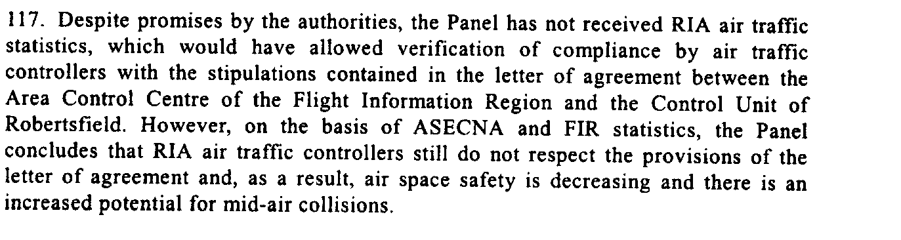

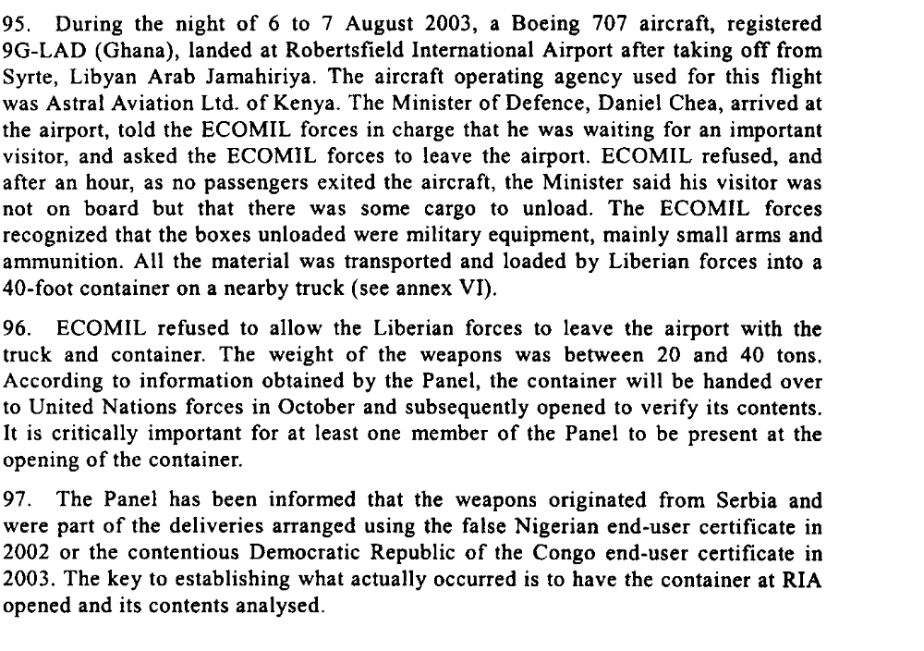

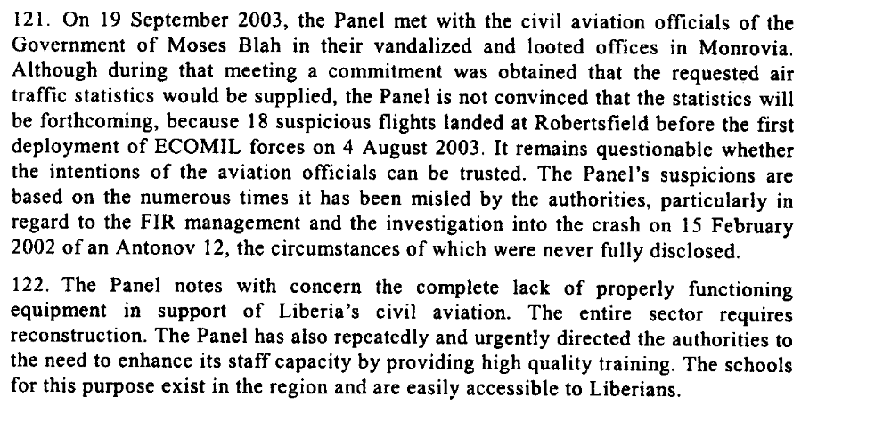

United Nations Security Council, Letter dated 28 October 2003 from the Chairman of the Security Council Committee established pursuant to resolution 1343 (2001) concerning Liberia addressed to the President of the Security Council.

Assessment

Medium-term compliance
X No or marginal compliance (1) | Medium low compliance (2) | Medium high compliance (3) | Full or almost full compliance (4)

Considerations underlying the assessment
The Government of Liberia did not authorize the Approach and Control Unit at Robertsfield International Airport to provide regularly to the Flight Information Region in Conakry statistical data related to aircraft listed pursuant to paragraph 29 above.

Depth of demand

Assessment

Level of depth of demand
Low depth of demand (1) | X Medium depth of demand (2) | High depth of demand (3)

Considerations underlying the assessment

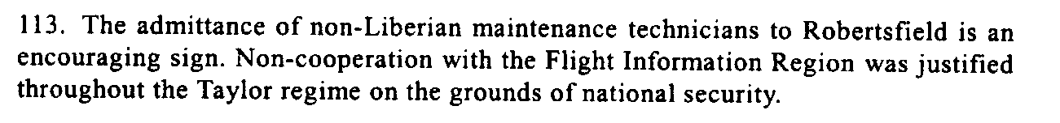

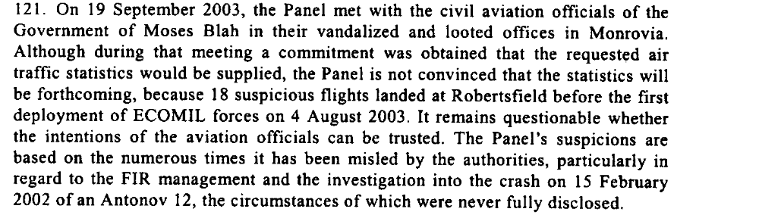

United Nations Security Council, Letter dated 28 October 2003 from the Chairman of the Security Council Committee established pursuant to resolution 1343 (2001) concerning Liberia addressed to the President of the Security Council.

Level of confidence about coding decisions

Level of confidence about coding decision
Extremely high | X High | Moderate

Comments to IPI (if any)

